Contribute to Content Discovery: Mitosis/Meiosis

Instructions:
Go online and look up content related to the assigned module. It can be videos or tutorials that help explain terms and concepts covered. It can be interesting podcasts, videos or articles that show the relevance or application of material covered in the module. Post a link to the website you find and give a short summary of between 100 to 200 words.

HOL VIRTUAL MICROSCOPE LAB.
Below are instructions for using the Hands-On Labs virtual microscope. A worksheet detailing what I want you to do is below that.

1. Log onto the Hands-On Labs website and click on our course, BIO 111.
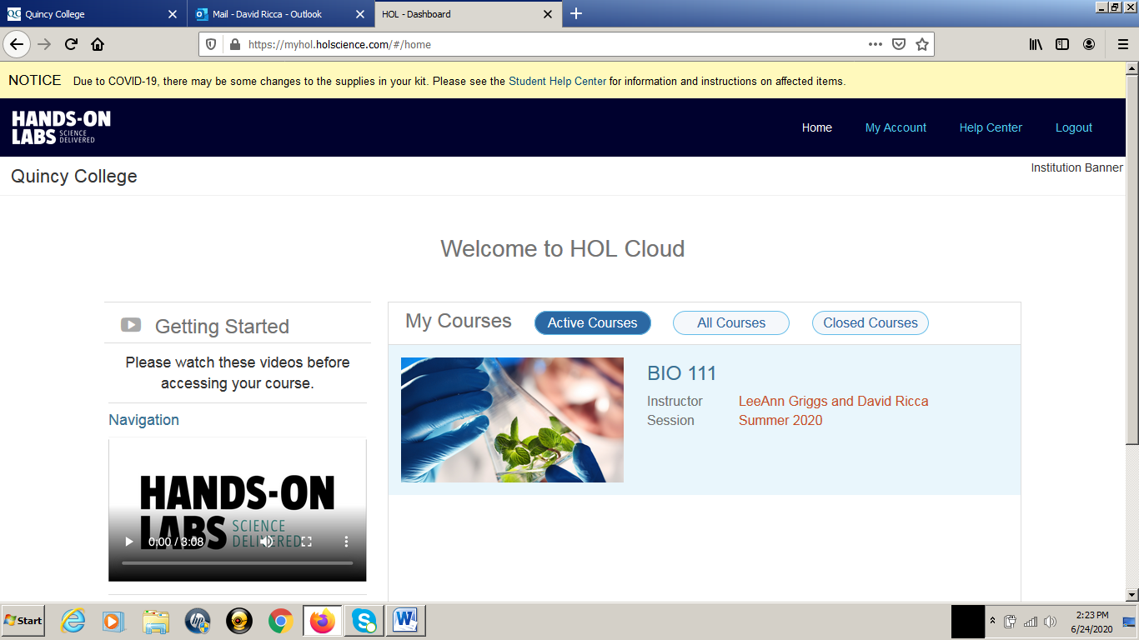

2. Click on “Using the V-Scope” under “Prerequisites”.
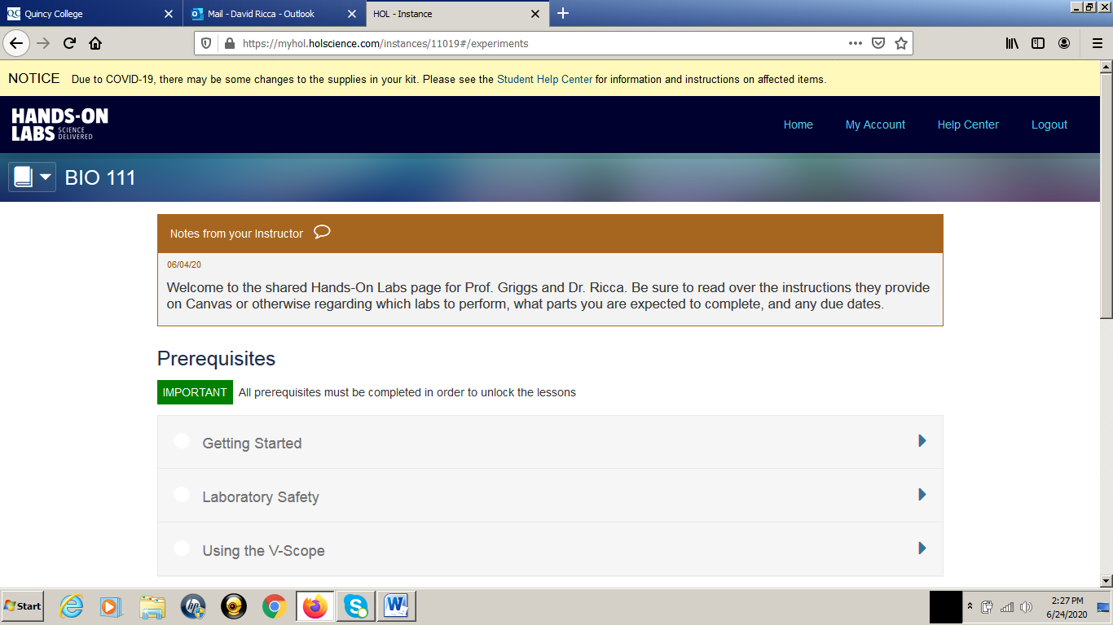
3. Click on “Exploration”, read the content and answer the questions. Do your best to answer the questions correctly. I will not grade you on them but you need to know the answers to operate the virtual microscope properly.
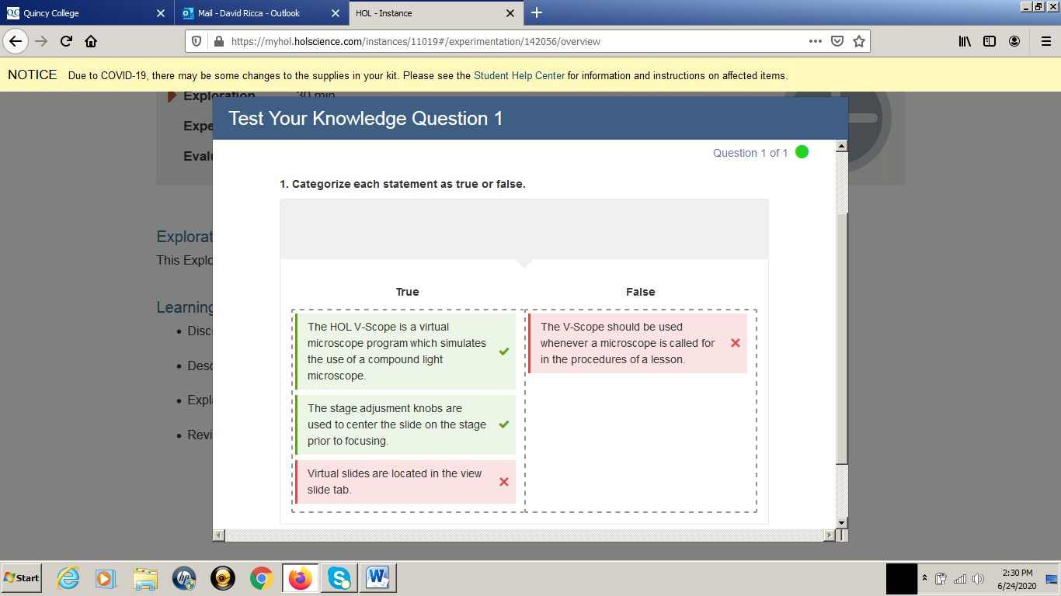

4. Eventually you will get to a page that looks like the screen shot below. Click on “Open the HOL V-Scope Program”.
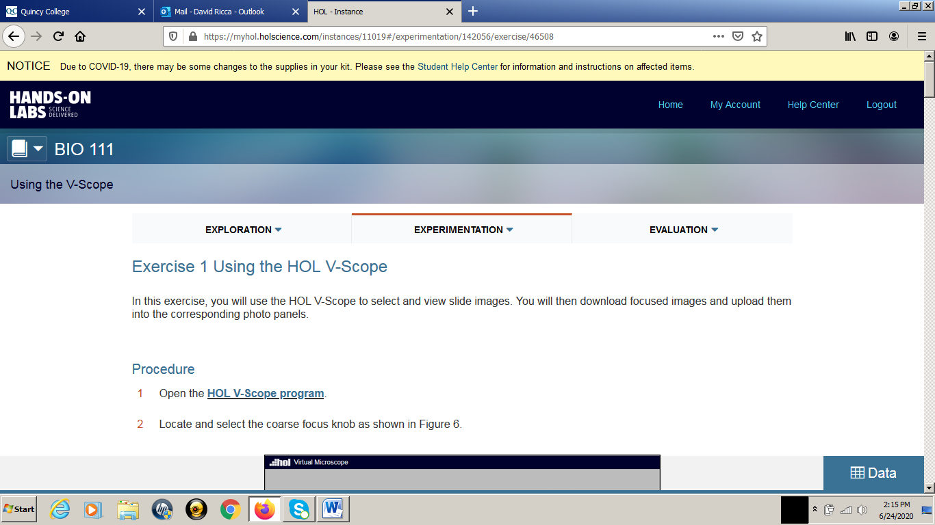

5. Here is the Virtual Microscope! You click on the picture of the microscope to enable the controls. Click on “Slide Library” to select from a number of slides. Note the helpful list of steps in the lower left. Descriptions of each microscope control are below.
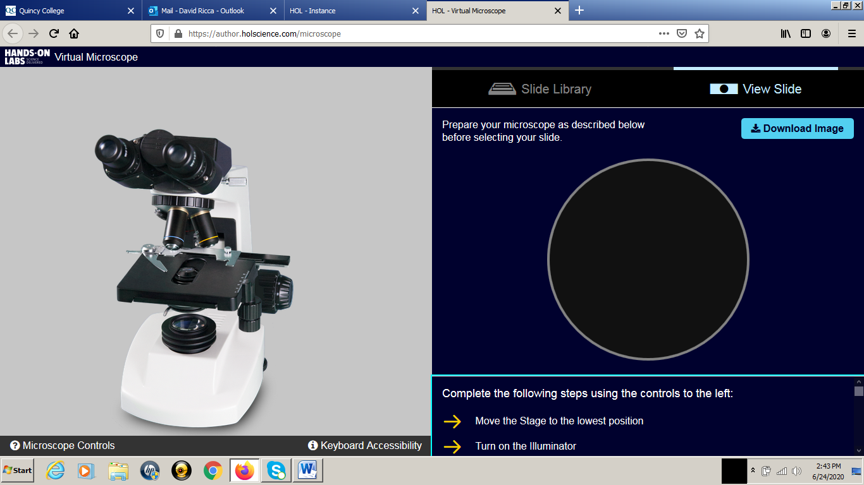

LIGHT SWITCH: Click this switch on the bottom to turn on the light. The light is still off in the screen shot below.
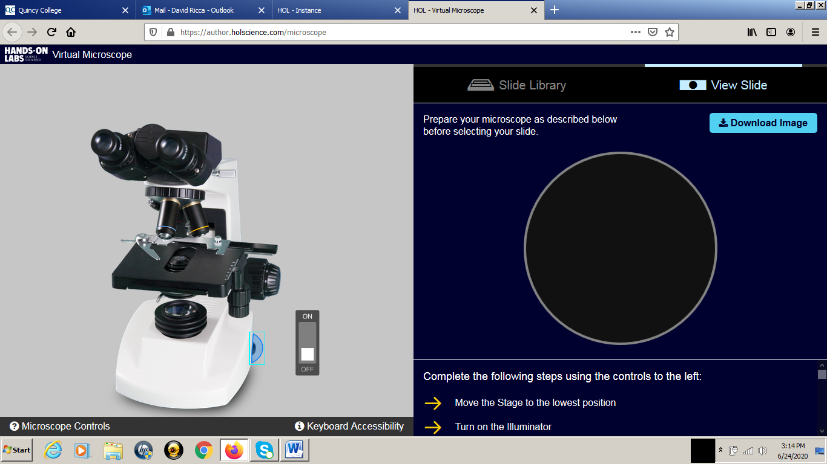

COARSE FOCUS: I clicked the larger, inner coarse focus knob. This moves the stage up and down on a real microscope, which changes the distance of the slide from the objective. This is used to focus the slide. You focus the slide by clicking and dragging the light blue slider on the vertical ruler. Use the up-arrow and down-arrow for greater control.
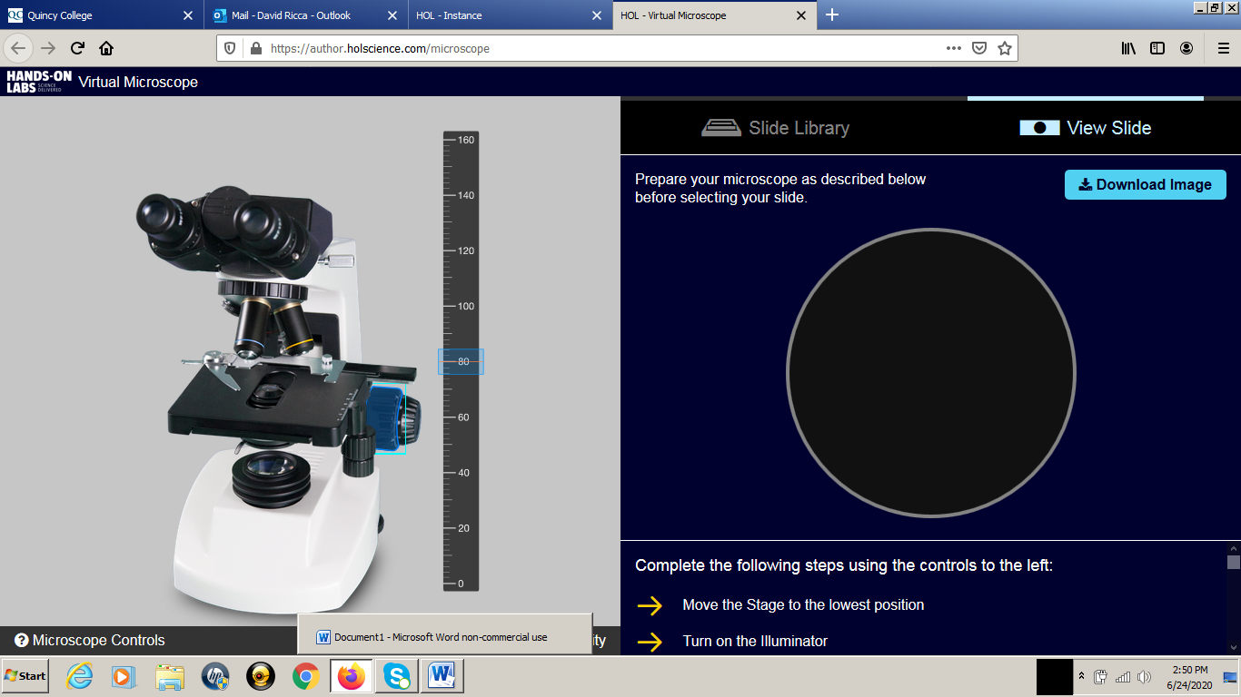

FINE FOCUS: I clicked the smaller, outer fine focus knob. This moves the stage up and down but not as much, so it’s easier to get a sharp focus. The up- and down-arrow keys give you even greater control.
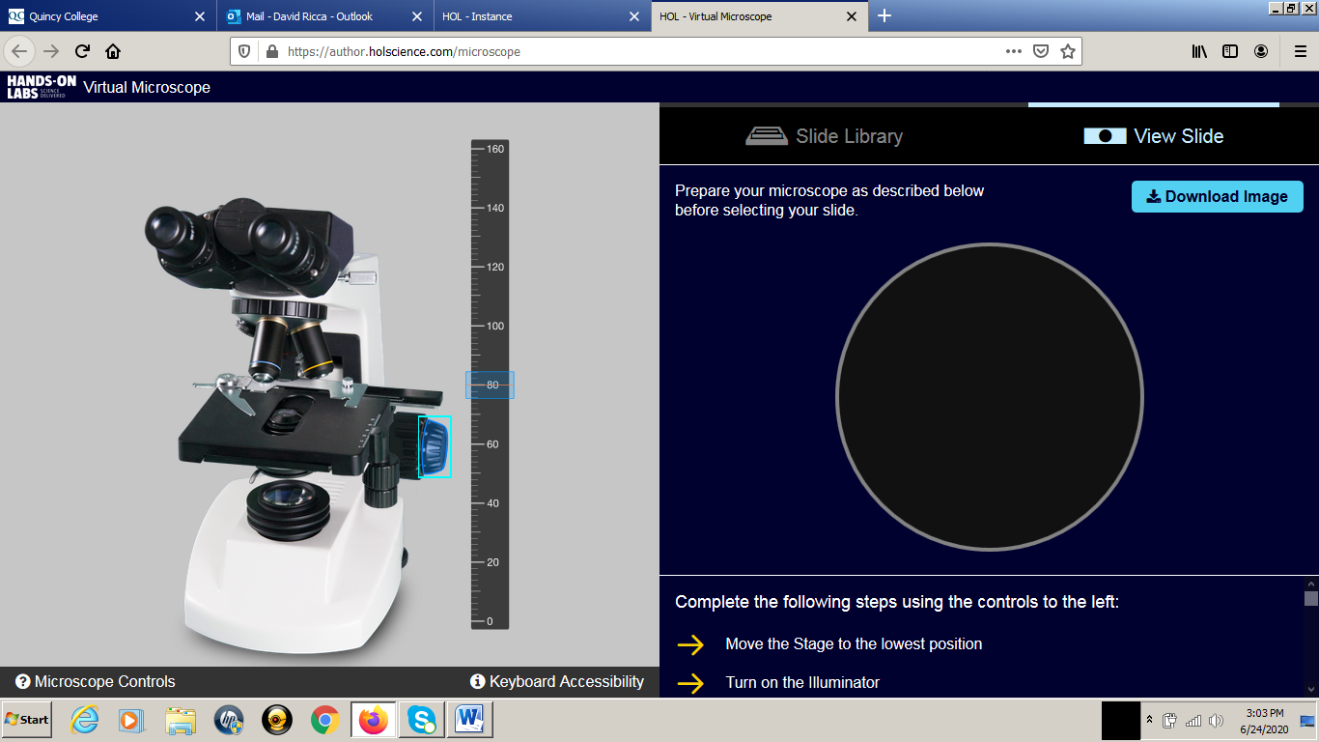
X-Y STAGE CONTROL: X-CONTROL: The knob moves the slide left-to-right (X-coordinate). Move the slider on the top to control this knob.
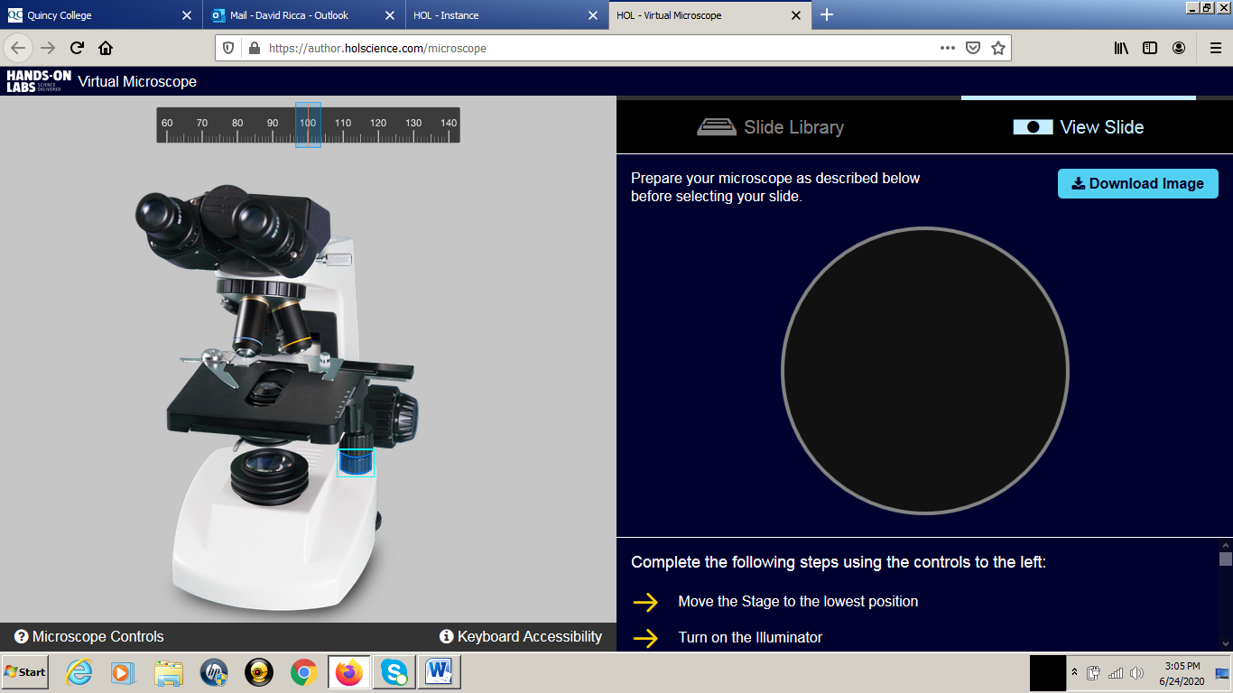

X-Y STAGE CONTROL: Y-CONTROL: The knob moves the slide front-to-back (Y-coordinate). Move the slider on the right to control this knob.
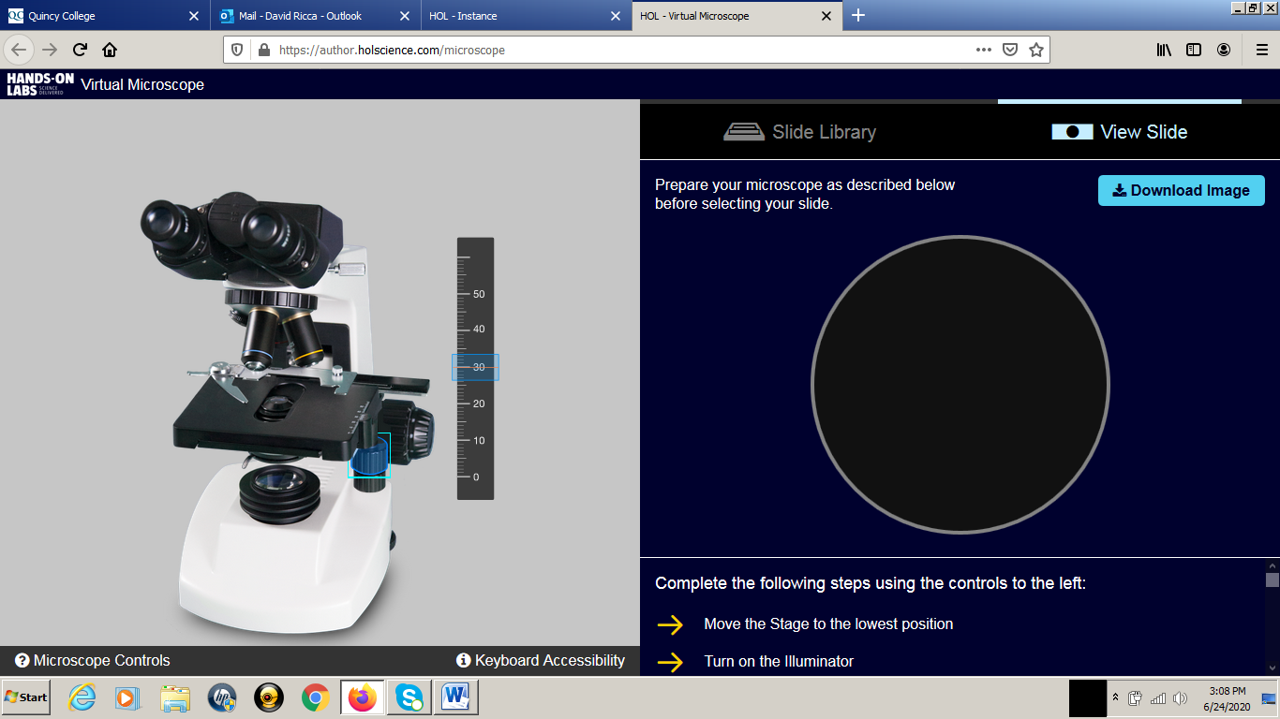

MAGNIFICATION: I clicked on the turret to enable choice of objective. The objectives are the lenses above the slide and each have a different magnification. Click on the circle with 4X, 10X and 40X to toggle between magnifications.
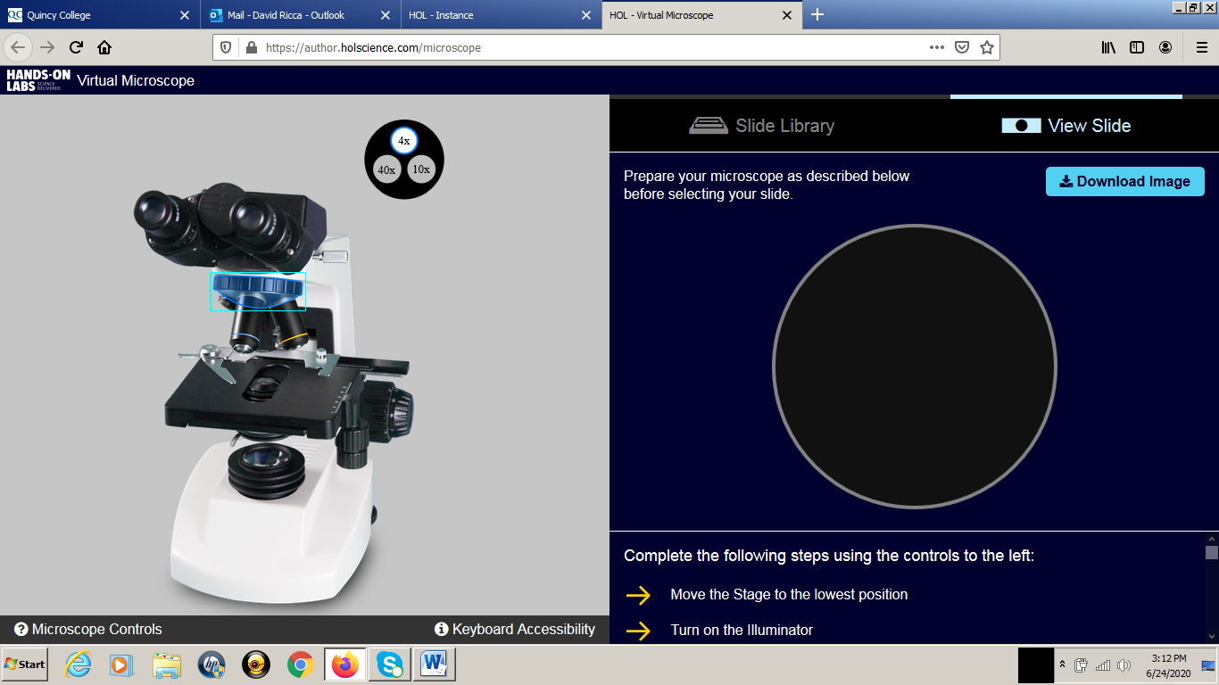

SLIDE LIBRARY: Click “Slide Library and choose your slide from the drop-down list. You can’t see my cursor, but I am just about to select “Daphnia”. You can see it in blue.
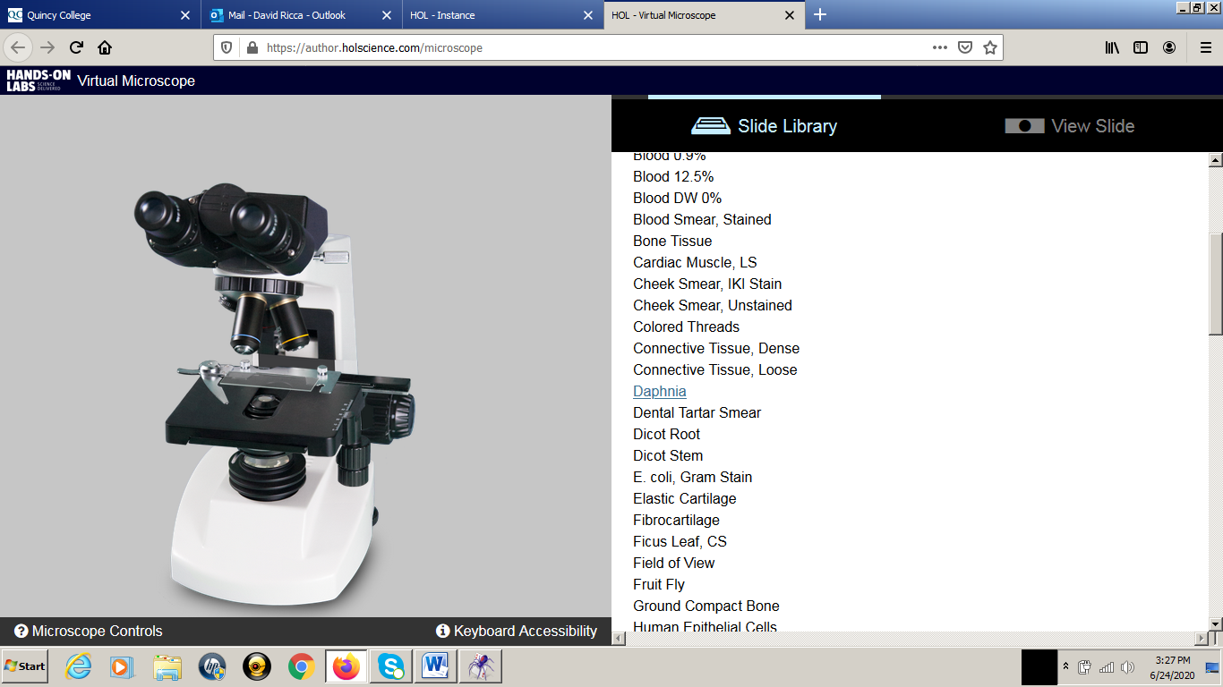

SLIDE POSITIONED AND FOCUSED: I used the X-Y controls and the coarse and fine focus controls to position and focus the Daphnia. Daphnia are big so I used the 4X objective.
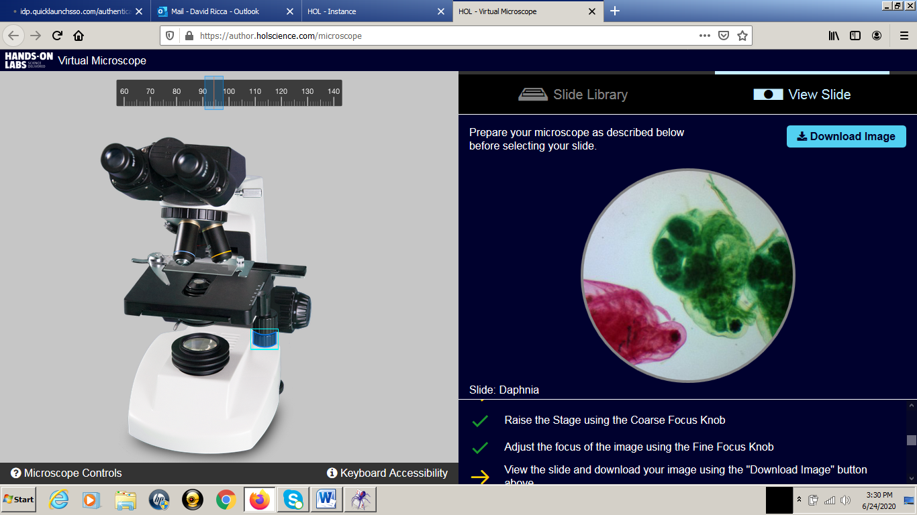

DOWNLOAD IMAGE: Click “Download Image” and save a picture of your slide. In this case, I chose to open the image in Windows Live Photo Gallery. You can also choose to save the file as an image. Be sure to save your file as a jpg or jpeg. Don’t save files with .pages or .heic file extensions.
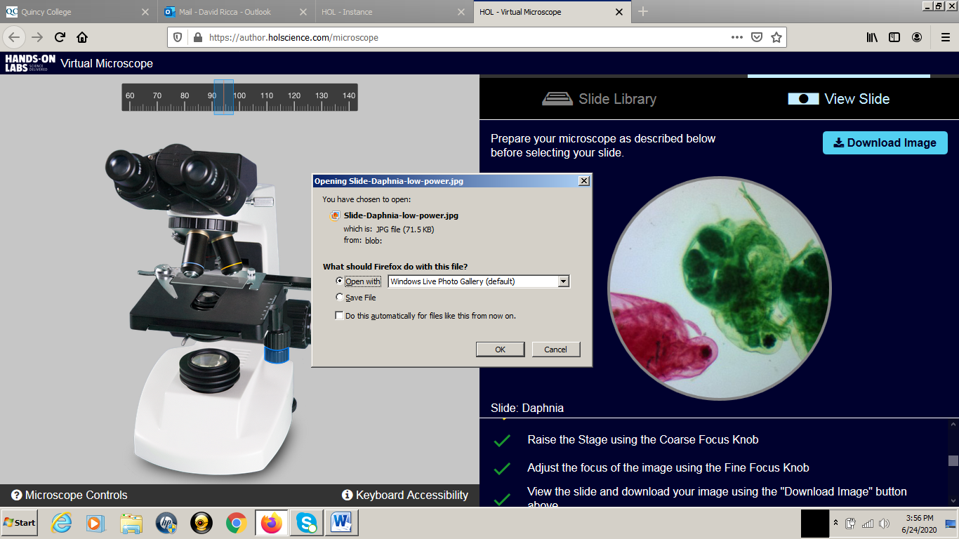

Here is a screen shot showing the Windows Live Photo Gallery.
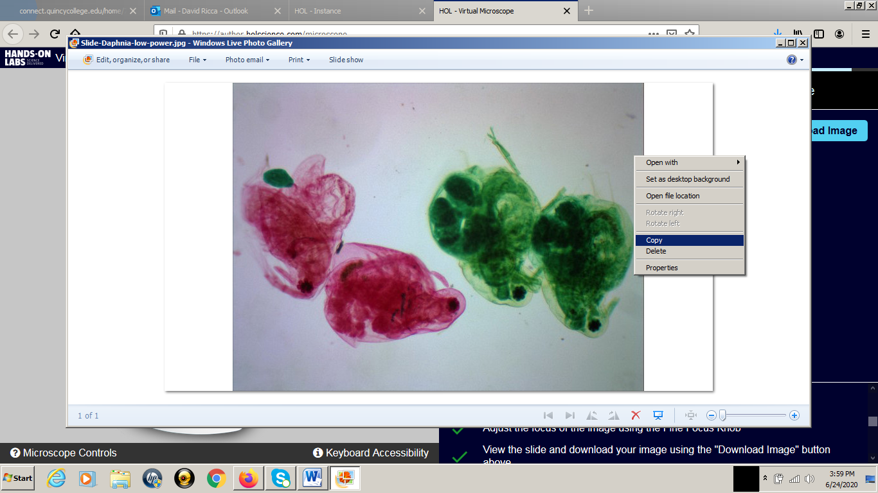

IMAGE PASTED DIRECTLY INTO MS WORD: Life is a lot simpler for all of us if you can paste your images directly into MS Word. Be sure that your image is centered and in sharp focus. This is what I will grade you on! Also label the image with the name of the slide chosen and the magnification used.

Daphnia. Photographed at 4X.
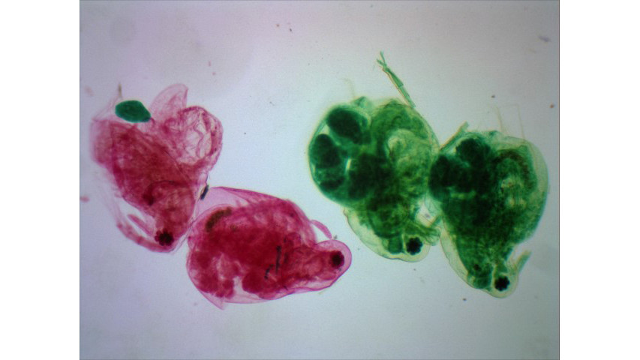
VIRTUAL MUCROSCOPE WORKSHEET Name:
Please do the following:
1. Provide three pictures, one at 4X, one at 10X and one at 40X. This will count as your picture and data.
A. Daphnia @ 4X
B. Ground Compact Bone @ 10X
C. Onion Root Tip @ 40X
Paste your Images Here:

Summary of Results:
Describe in your own words, the steps needed to center and focus a slide under a microscope. Write your description as if you were explaining how to use a microscope to another student. Use the following terms in your explanation: coarse focus knob, fine focus knob, X-Y stage control, objective lens, and objective magnification.

